**PIR sensor and project on this sensor**

**By Prathyusha Nareshkumar**

* **Introduction:**

PIR sensors allow you to sense motion, always used to detect whether a human has moved in or out of the sensors range. They are small, inexpensive, low-power, easy to use and don't wear out.

* **How PIR Sensor Works:**
  + The PIR sensor itself has two slots in it, each slot is made of a special material that is sensitive to IR.
  + When the sensor is idle, both slots detect the same amount of IR, the ambient amount radiated from the room or walls or outdoors.
  + When a warm body like a human or animal passes by, it first intercepts one half of the PIR sensor, which causes a positive differential change between the two halves.
  + When the warm body leaves the sensing area, the reverse happens, whereby the sensor generates a negative differential change. These change pulses are what is detected.

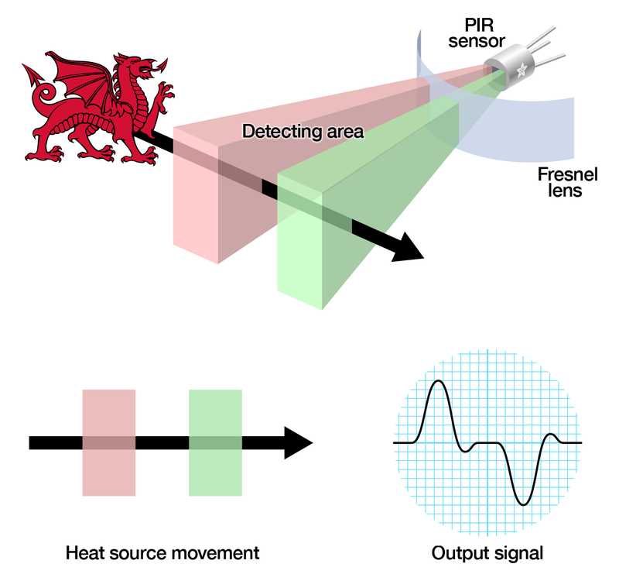

* **The PIR Sensor:**
  + The IR sensor itself is housed in a hermetically sealed metal can to improve noise/temperature/humidity immunity.
  + There is a window made of IR-transmissivity material (typically coated silicon since that is very easy to come by) that protects the sensing element.
  + Behind the window are the two balanced sensors.

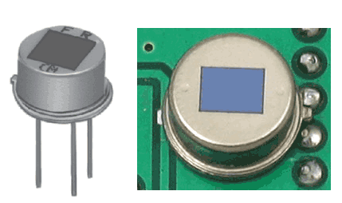 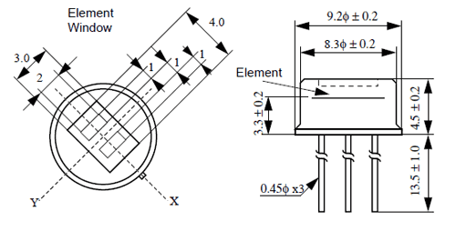

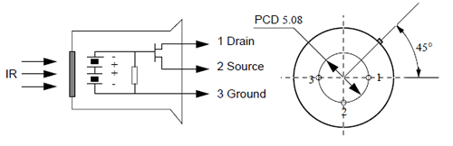

* These images show the internal schematic of the sensor. There is actually a JFET inside (a type of transistor) which is very low-noise and buffers the extremely high impedances of the sensor into something a low-cost chip (like the BIS0001) can sense.
* **Lenses and cost of sensor :**
  + PIR sensors are rather generic and for the most part vary only in price and sensitivity.
  + The lens costs only a few cents and can change the breadth, range, sensing pattern, very easily.
  + In the diagram up top, the lens is just a piece of plastic, but that means that the detection area is just two rectangles. Usually we'd like to have a detection area that is much larger. To do that, we use [a simple lens](http://en.wikipedia.org/wiki/Lens_%28optics%29) such as those found in a camera: they condenses a large area (such as a landscape) into a small one (on film or a CCD sensor). For reasons that will be apparent soon, we would like to make the PIR lenses small and thin and moldable from cheap plastic, even though it may add distortion. For this reason the sensors are actually [Fresnel lenses](http://en.wikipedia.org/wiki/Fresnel_lens):

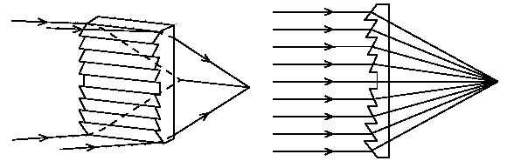

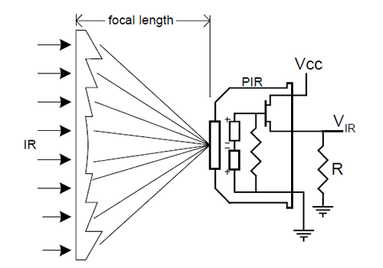

  As we have a much larger range, however, we actually have two sensors, and we don’t want two really big sensing-area rectangles, but rather a scattering of multiple small areas. So what we do is split up the lens into multiple section, each section of which is a Fresnel lens.

* Pinouts and Features of the sensor :
  + PIR modules have a 3-pin connection at the side or bottom.
  + One pin will be ground, another will be signal and the final one will be power.
  + Power is usually 3-5VDC input but may be as high as 12V.
  + 2 different operating modes - Repeatable and Non-Repeatable
  + Can cover a distance of about 7 meters and about 120 degrees
  + Low power consumption
  + Operating Temperature is between -20 degree Celsius and 80 degree Celsius.
* **Working of PIR sensor :**

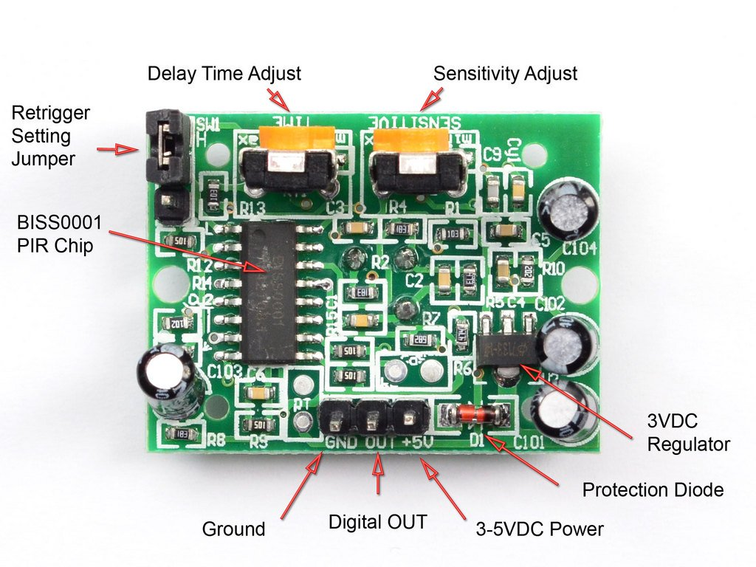

* PIR sensor consists of a Pyroelectric sensor which generates energy when exposed to human body. Therefore, when a human or anybody comes in a specific range of the sensor, the body emits heat energy in the form of infrared radiations. Which in turn is detected as motion by the sensor. Hence it is called Passive Infrared Sensor. It is called Passive because it does not produce any energy, it just detects the energy produced by the external body.
* Sensor contains Fresnel lens which focuses all the signals on the sensor.
* Has 3 pins as mentioned above. Along with 2 potentiometers, 1 for adjusting the sensitivity of the sensor (up to 7 m) and the other for adjusting the delay time (0.3s to 5 mins).
* Also contains 3 more pins for selecting the trigger modes. First mode is “Non-Repeatable trigger”. When the sensor output is high and the delay time is over, the output will automatically change from high to low.
* Next, the “Repeatable trigger” will keep the output high until the detected object is present in the sensor’s range. The trigger modes can be changed using retrigger setting jumper.

. **Mini project on Security alarm system using PIR sensor, adafruit IO, IFTTT, esp8266**

**Objective:**

To construct the Security alarm system using PIR (Passive infra-red) sensor, esp8266(Nodemcu) ,Adafruit IO cloud ( to display the variation of values detected by the sensor)and IFTTT (to trigger a notification showing the details of variation in the mobile phone through IFTTT application).

So the idea of the project is to create notifications alert system. Nodemcu can be connected to internet through Wi-Fi and notifications can be send to concerned person if intrusion is detected by the PIR sensor.

**Hardware and applications required or used:**

PIR sensor, esp8266, Arduino IDE, Connecting wires, Breadboard, a LED, a Buzzer, Adafruit IO account (username and password to publish the values into feeds), IFTTT account ( to trigger notification through app in the phone ), resistors.

**Circuit Diagram:**

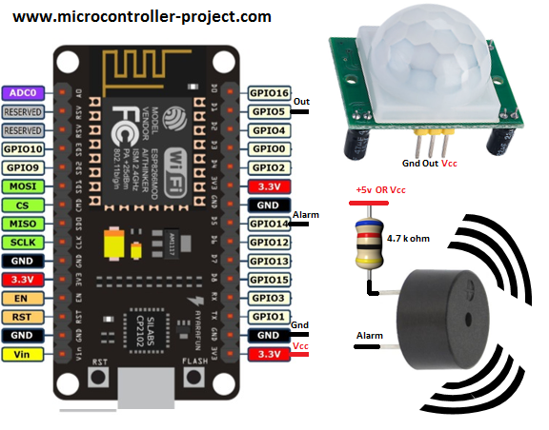

**Working of the project:**

* The PIR sensor senses the presence of any object or any movement of human body in a particular region.
* The input signal from sensor which is in the analog form is transferred to esp8266 (D1 pin), which in turn converts it into a digital format (binary numbers 0 and 1) and write into the led pin and Buzzer pin (D2 and D4 pins of ESP8266) respectively.
* If the value is greater than 0 LED will glow and the buzzer will go on, else it doesn’t.
* The values sensed by sensor are published in the adafruit IO server.
* IFTTT app which is connected to adafruit IO triggers a notification with message if the PIR sensor detects motion, which contains the feed value, in the mobile phone via IFTTT application installed in the phone.

**Procedure:**

1. Connect the components as per the above given circuit diagrams using connecting wires.
2. Write the code in the Arduino IDE application.
   1. the code is available in this link:

<https://drive.google.com/file/d/1W_0MiceC6DpCeWP3dLPLrCdyhypIY79s/view?usp=sharing>

1. Create a feed in Adafruit IO with name PIR sensor feed and a dashboard with stream and gauge (lower state-0 and higher state -1) blocks. Create blocks (image 2) and sensor (Image 1) as given below:

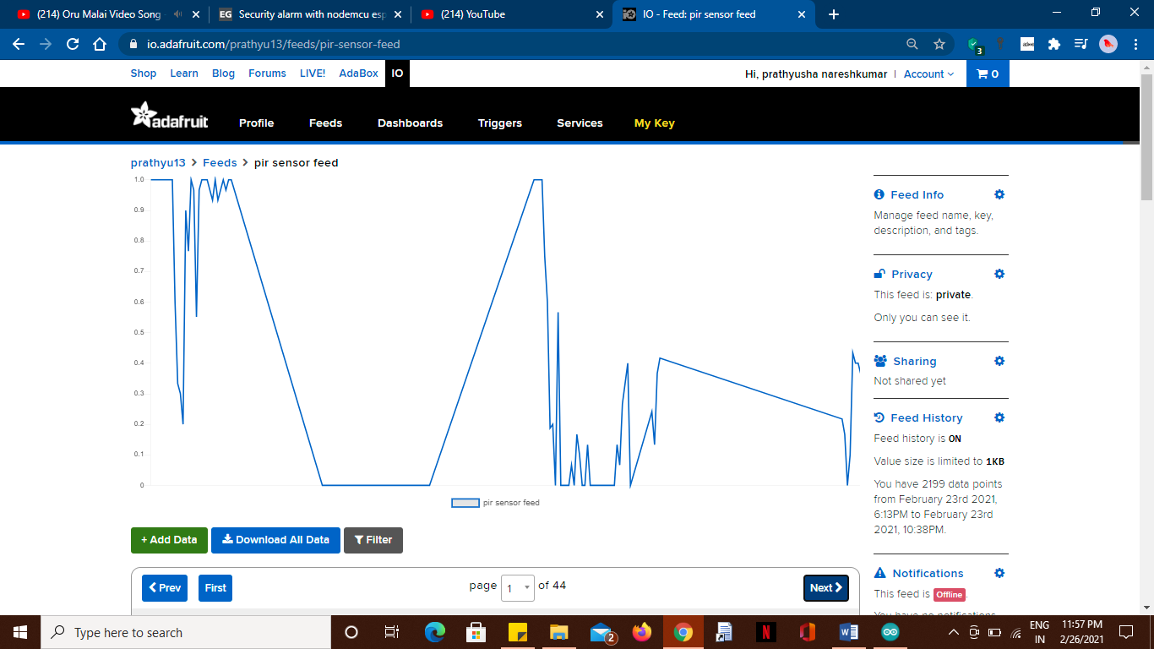

Image 1

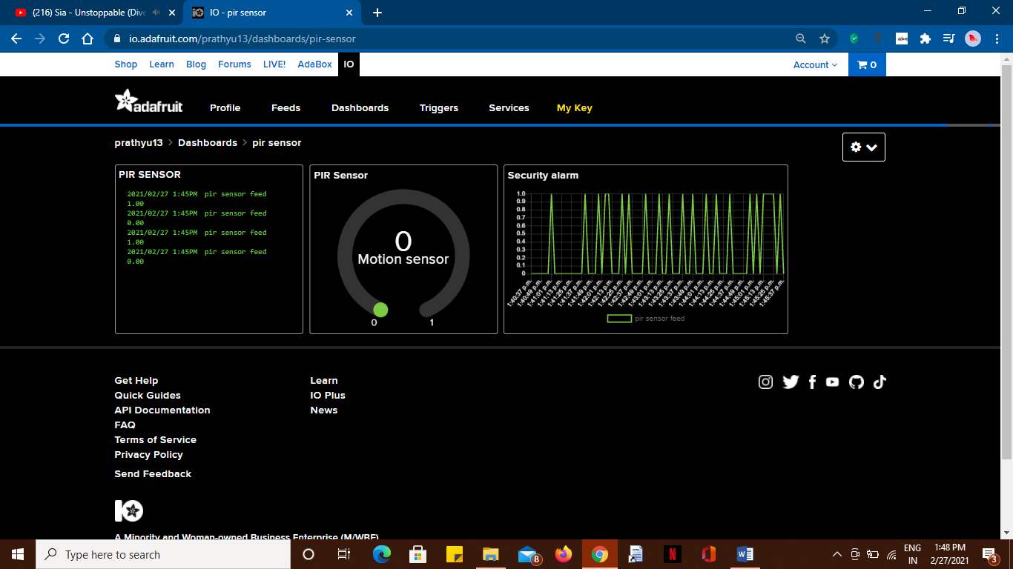

Image 2

1. Connect the blocks with the PIR sensor feed to get a clear data history and variation in values.
2. Open IFTT app, Create an applet by connecting Adafruit IO with notification trigger. Follow the image to create an applet: Image 3.
3. After connecting IFTTT with Adafruit IO, upload the code in Arduino IDE into esp8266.

**Result:** Thus the project is created to show the working of PIR sensor using esp8266, Adafruit IO, IFTTT.

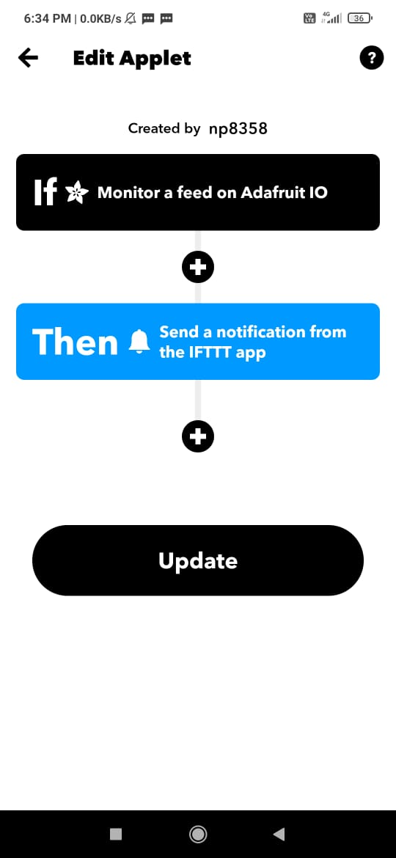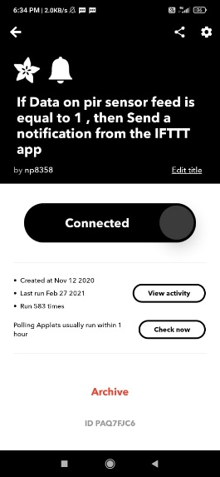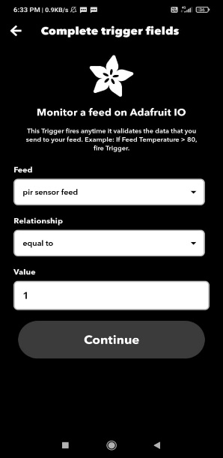

Image 3

**Snap of circuitry:**

